FACULTY EVALUATION
Programme Name: Social Entrepreneurship Development Program (SEDP)- Advance Tanzania (2nd February - 6th February 2026)
Session: Establishing Social Impact/ Measuring Social Impact
Faculty Name: Tim Kipchumba
No. of Respondents: 17
No. of Participants: 17
Evaluation Parameter | (%) Individual Score | (%) Programme Average
Punctuality (Commencement and Completion of Sessions) | 98 | 95
How well do you understand the core concepts presented? | 86 | 90
Rate your confidence in applying the new skills learnt | 89 | 91
Degree of Faculty preparedness for the sessions | 95 | 94
Content and methodology of the program | 97 | 94
Quality of class and group discussions | 94 | 92
The information presented in the course is relevant to my work (ministry) | 94 | 94
Average scores | 93 | 93

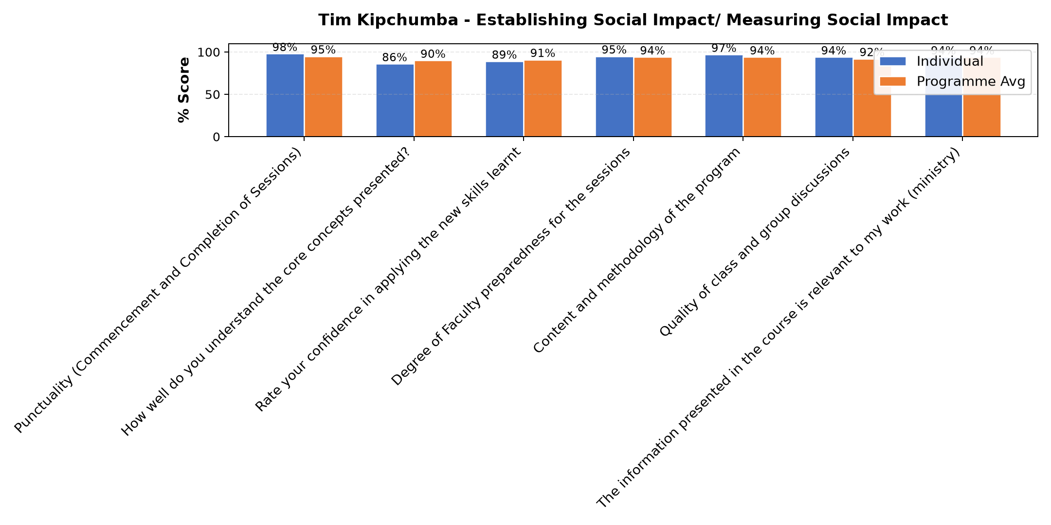

Comments & Feedback
- • Namna ya kuendesha biashara Kwa ufanisi.
- • Protocols
- • Ni Mwalimu bora.
- • Ana uzoefu mzuri.
SUBMITTED THROUGH:
SBS Evaluation Automation System

